Title of the paper (style Title, Title Style)
Author’s name and surname (style: Authors)
Affiliation, Institution, Address, e-mail (style: Author data)
Author’s name and surname
Affiliation, Institution, Address, e-mail
Author’s name and surname
Affiliation, Institution, Address, e-mail
Abstract (style: Abstract heading)
Abstract text, Abstract text, Abstract text, Abstract text, Abstract text, Abstract text, Abstract text, Abstract text, Abstract text, Abstract text, Abstract text, Abstract text, Abstract text, Abstract text, Abstract text, Abstract text, Abstract text, Abstract text, Abstract text, Abstract text, Abstract text, Abstract text, Abstract text, Abstract text, Abstract text, Abstract text... (style: Abstract text)
(max. 300 words)
Keywords: keyword 1, keyword 2, keyword 3, etc. (max 5 words)

Introduction (style: Title of the paragraph)
The current period is characterized by the development of the world market with consequences reaching deep into culture, identity and lifestyles. Globalization of economic operations is accompanied by waves of cultural transformation, a process called cultural globalization. As a counterbalance for globalization, there is localization Theoreticians regard... (style: Paragraph text)
Title of the paragraph (style: Title of the paragraph)
The economy in a globalized world is an arena for competing cities and regions. Today, cities are drivers of social and cultural development, and as such they have the power to stimulate themselves, regions and states to grow and develop. To achieve a better position in a system determined by a network of global cities, they must be capable to strongly attract the best organizations, professionals. Each of the mentioned components of the city as a product represents individual levels of the overall experience and perception of a city. The social space of the city is the frame... (style: Paragraph text)
Title of the paragraph (style: Title of the paragraph)
The popularity of this segment of tourism, as a branch of the economy has considerably grown in the last decade. Basic causes and motives are noted in the growth of interest in culture; increase of cultural capital; growth of the aged population in developed countries... (style: Paragraph text)
Title of the sub-paragraph (style: Title of the sub-paragraph)
It is important to mention that manifestations, customs, etc. sometimes need to be altered and adapted in a manner that will bring them closer to the audience ... (style: Paragraph text)
Table 1: Table title (style: Caption, Table title)
 | Title of the column | Title of the column
Title of the row | text/value | text/value
Title of the row | text/value | text/value
Title of the row | text/value | text/value
Title of the sub-paragraph (style: Title of the sub-paragraph)
In addition to the above mentioned, the portal also contains a calendar of events that are organized, and have the goal to acquaint visitors with history, tradition and local cultural characteristics... (style: Paragraph text)
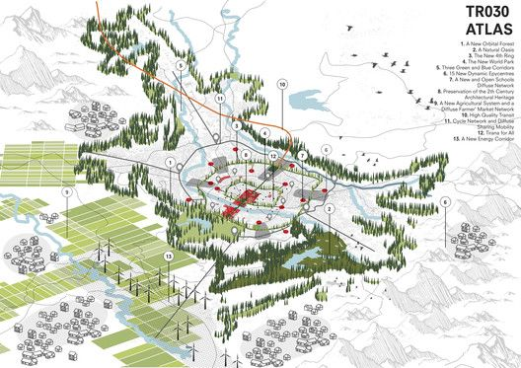
Figure 1: Figure title (style: Figure title) - Authors are requested to respect the copyrights of sources that have been takenfrom other authors or organizations. Figure size 300dpi
Conclusions (style: Title of the paragraph)
As drivers of social and cultural development, cities stimulate themselves, regions and states to grow and develop. To achieve a better position within the system of the network of global cities, cities are orienting toward entrepreneurial activities with the goal to find ... (style: Paragraph text)
References (style: Title of the paragraph)
Book:
Okuda, Michael, and Denise Okuda (1993). Star trek chronology: The history of the future. New York: Pocket Books.
Book chapter:
Ramírez, Ángeles (2010). “Muslim Women in the Spanish Press: The Persistence of Subaltern Images.” In Muslim Women in War and Crisis: Representation and Reality, edited by FaeghehShirazi, 227–44. Austin: University of Texas Press.
Journal article:
Bogren, Alexandra (2011). “Gender and Alcohol: The Swedish Press Debate.” Journal of Gender Studies 20, no. 2 (June): 155–69.
Internet source:
Google (2012). “Privacy Policy.” Google Policies & Principles. Last modified July 27. Accessed January 3, 2013. http://www.google.com/policies/privacy/.
Blog entry or comment:
Becker, Gary (2012). “Is Capitalism in Crisis?” The Becker-Posner Blog, February 12. Accessed February 16, 2012. http://www.becker-posner-blog.com/2012/02/is-capitalism-in-crisis-becker.html.
The list of references should be arranged alphabetically.

Additional note:
The paper should be named as follows: IFAU 19 paper_name_surname.docx
Full papers should be submitted by email

Email address: 2019.ifau@gmail.com
Authors are asked to respect and use established styles and defined maximum (8 pages) of pages for the full paper.

Corresponding author

